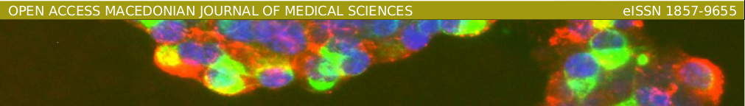

Copyright Form

Manuscript Number: _________________
This Agreement is made with Open Access Macedonian Journal of Medical Sciences (OAMJMS). The Agreement is for the Article submitted by you (“Author”) for publication Open Access Macedonian Journal of Medical Sciences (OAMJMS). To enable publishing the Article in Open Access Macedonian Journal of Medical Sciences (OAMJMS) (“the Journal”), the ownership of copyright must be established. Please read and complete the form below (Section A plus Section B) and return one copy to the address given below. There are explanatory notes to this Agreement, which also form part of the Agreement.
The Article cannot be published until this signed Agreement is received by OAMJMS.

SECTION A: Author’s Warranty (Please print your details)
Name: ................................................................................................................................................................................................................
Address: ................................................................................................................................................................................................................
................................................................................................................................................................................................................
Article title: ................................................................................................................................................................................................................
................................................................................................................................................................................................................
Names of all authors in the order in which they appear in the Article:
................................................................................................................................................................................................................
................................................................................................................................................................................................................
................................................................................................................................................................................................................
In consideration of the publication of the Article in the above Journal, I hereby warrant and undertake:
- a. that this Article is an original work, has not been published before and is not being considered for publication elsewhere in its final form either in printed or electronic form.
- b. that I have obtained permission from the copyright holder to reproduce in the Article (in all media including print and electronic form) material not owned by me, and that I have acknowledged the source;
- c. that this Article contains no violation of any existing copyright or other third party right or any material of an obscene, indecent or otherwise unlawful nature and that to the best of my knowledge this Article does not infringe the rights of others;
- d. that I will indemnify and keep indemnified the Editors, Open Access Macedonian Journal of Medical Sciences against all claims and expenses (including legal costs and expenses) arising from any breach of this warranty and the other warranties on my behalf in this Agreement;
- e. that in the case of a multi-authored Article I have obtained copyright assignment from all co-authors, in writing, and authorization to enter into this Agreement on their behalf and that all co-authors have read and agreed the above warranties;

- Author: Signed: ..................................................................... Date: ........................................................

SECTION B: Copyright Assignment
This is an open-access article distributed under the terms of the Creative Commons Attribution License, which permits unrestricted use, distribution, and reproduction in any medium, provided the original author and source are credited. Notwithstanding the above, I retain all proprietary rights other than copyright, such as patent and trade mark rights and rights to any process or procedure described in the Article.
Author: Signed: ..................................................................... Date: ........................................................
In signing this form, the signee asserts that any authors not signing have authorised the signee to do so on their behalf, and that the manuscript submitted has been approved by these authors in the form in which it has been submitted, and that the warranties given above have been read and agreed by all authors.

________________________________________________________________________________________________________________________
Scientific Foundation SPIROSKI Skopje, Rajko Zhinzifov No 48, 1000 Skopje, Republic of North Macedonia
UBIN: 5889243 | VAT: 4030004519877 | Tel.: +389 71 212233 | https://foundationspiroski.eu/ | oamjms@foundationspiroski.eu
_____________________________________________________________________________________________________________________

